Team meeting

Date: 15-02-2020

Time: 17:20（u.k. time）

Attendants:

Jinwen Yuan (Uppsala University biotechnologist)

Will Wei (Entrepreneur)

Agenda :

**§1**  Choose meeting secretary

Will

**§2** Determination of agenda

Will

**§3**  Updates from team members

* Jinwen:

idea: Airbnb for laboratory apparatus mapping, finding, sharing, training, helping

Potential problem: Ambiguous ownership for apparatus.

potential competitor： <http://yqgx.tsinghua.edu.cn/webSite/websiteAction.do?ms=toLabList>

* Will Wei:
  + Give a talk about how to use GitHub for this project.

<https://github.com/bioopenner/Bio-Umbrella>

* + Set up operation protocol for different scenarios in this business.
* scenarios：meeting
* (1) planning meeting（Monday，before standup meeting），60 mins weekly，core team will attend. purpose:1, learning global （every idea has its premises to be true, so we need to figure that out and rank them）; 2, prioritisation(according to the ranking of premises, we will verify the most important one); 3, tasking(design the experiment and allocate the assignments).

agenda: 1hypotheses to test

2 experiment prioritisation

3 experiment tasking

* (2) standup meeting(every morning before working), 15 mins daily, core team will attend.

agenda: 1 what is the daily goal (both the team and everyone)

2 how to achieve that goal

3 what is in the way (what is your problem if you have today)

* (3) learning meeting, 60 mins weekly (at the end of Friday), core team and extended team,

agenda: 1 gather evidence (because we did some experiments in this week, so we must have gotten some results to either support or deny our hypotheses. we need to gather those results to be our evidence)

2 generate insights (after gathering evidence, we need to reflect and conclude so that we can decide what to do next )

3 revisit our strategy (check our business model, value map, and hypotheses list, so that we can know whether we are on a consistent way, or we need to fix the strategy)

* (4) retros meeting, 20 mins biweekly, core team will attend, purpose: 1, went well ; 2, to fix; 3, to try

agenda: 1 what is going well

2 what needs to be improved

3 what to try next

* (5) deciding meeting, 60 mins monthly, stokeholders, extended team and core,

agenda: 1 what you have learnt

2 what is blocking the progress

3 pivot/ persevere / kill decision(change the idea)

**§5**  Planning discussion

1. Paper Prototype building

1.1 value propositions were proposed at the last meeting, and today we have added another value that is Airbnb for epuipments

1.2 Will try to draw the paper prototype

1.3 will try to find big problems

1.3.1 case study of change

<http://www.zhenfund.com/>

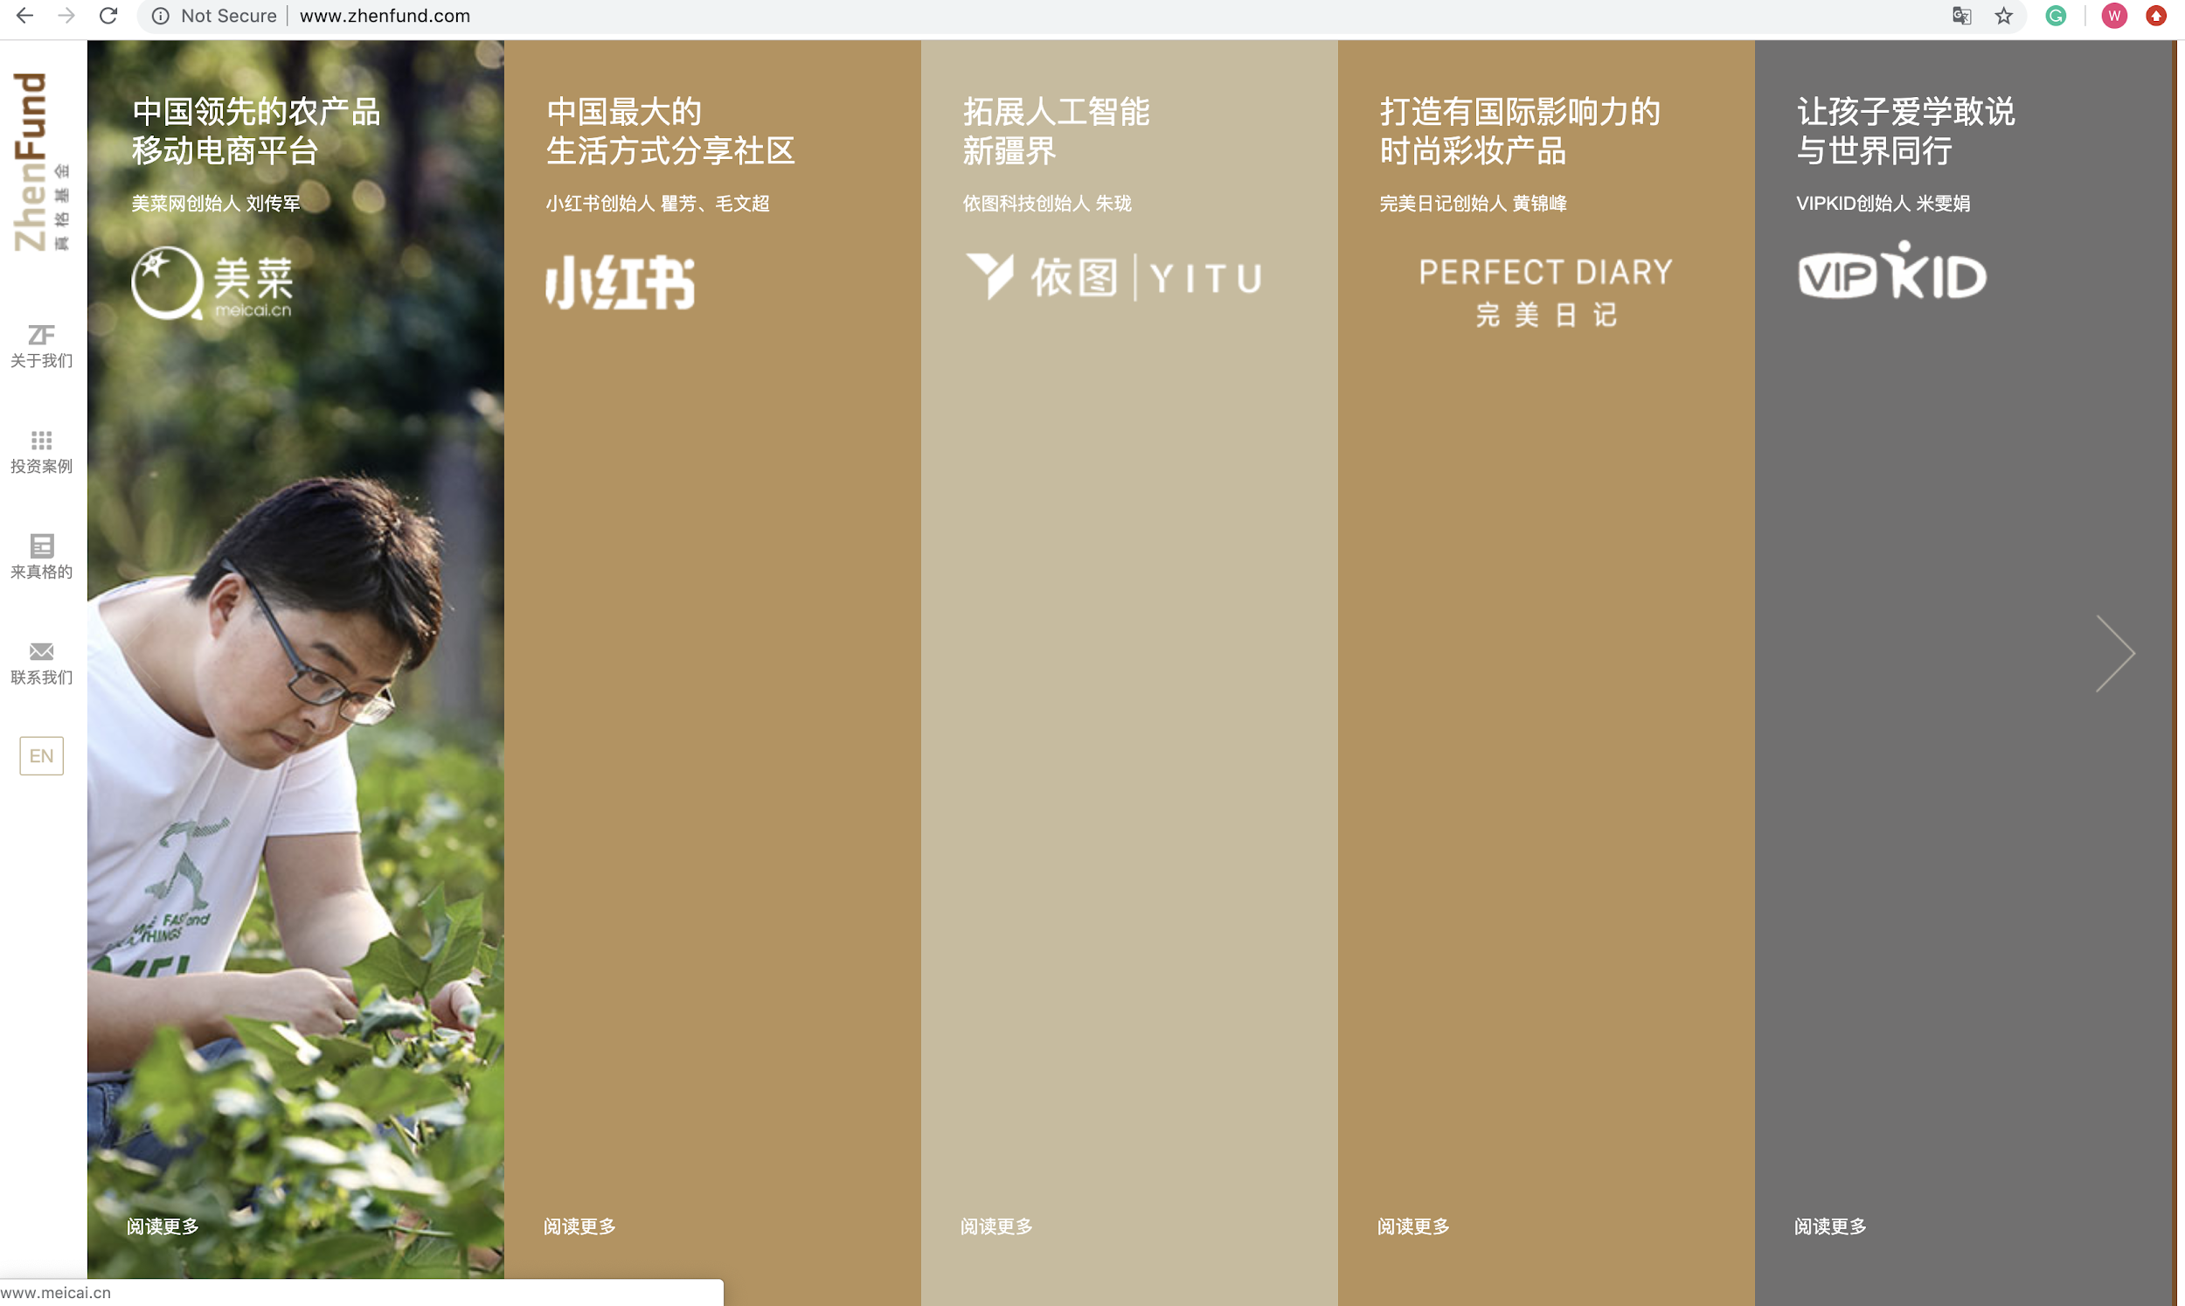

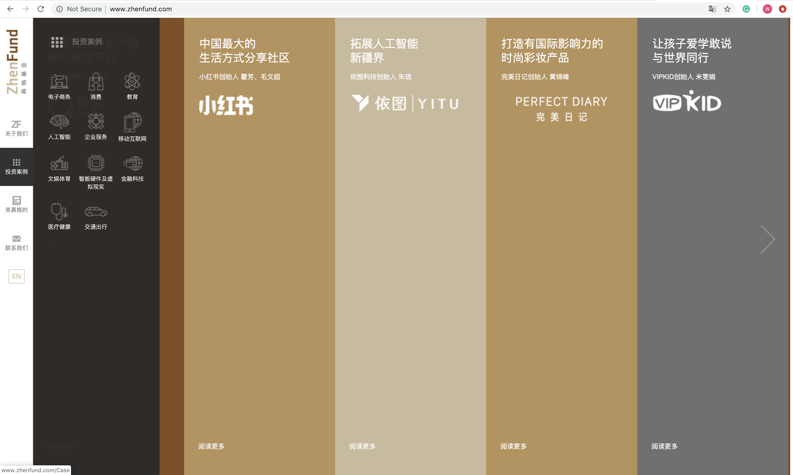

**§6** Plan for the rest of the meeting

5 mins, talk Airbnb model further,

**§9** Next meeting date and time

Big problems meeting for Jinwen and Will

Sunday, 14:00 (U.K. time)

next Monday, the agenda will be adopted

**§10** Meeting closes

Meeting closed at 18:23